Pharmaceutical Items Reimbursement Form
Please complete and sign this form to be reimbursed for pharmaceutical items relating to your claim. Please attach itemised receipt(s) to this form and send to your case manager to enable prompt processing and payment
Name: Claim Number: RTW Specialist:

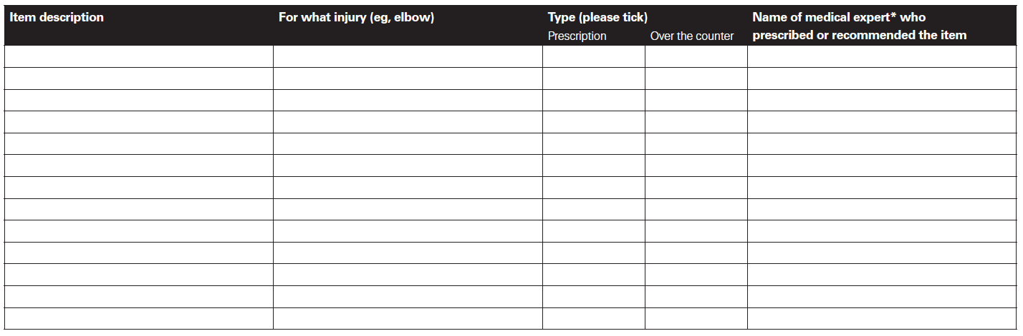

Declaration: I declare that the pharmaceutical items listed above are for my compensable injury and have been recommended by a medical expert or prescribed by a legally qualified medical practitioner.
Claimant signature: _________________________________________________________ Date: ________/________/________
*A medical expert is a legally qualified doctor, dentist, psychologist, optician, physiotherapist, chiropractor, podiatrist, occupational therapist, speech pathologist or osteopath. Non-prescription pharmacy items will only be reimbursed on recommendation of a medical expert,

